**3.4 I can respond appropriately to problems with multiple page web sites.**

If a problem was found with one of my web pages, such as the home page, I would navigate to that page on Visual Studio.

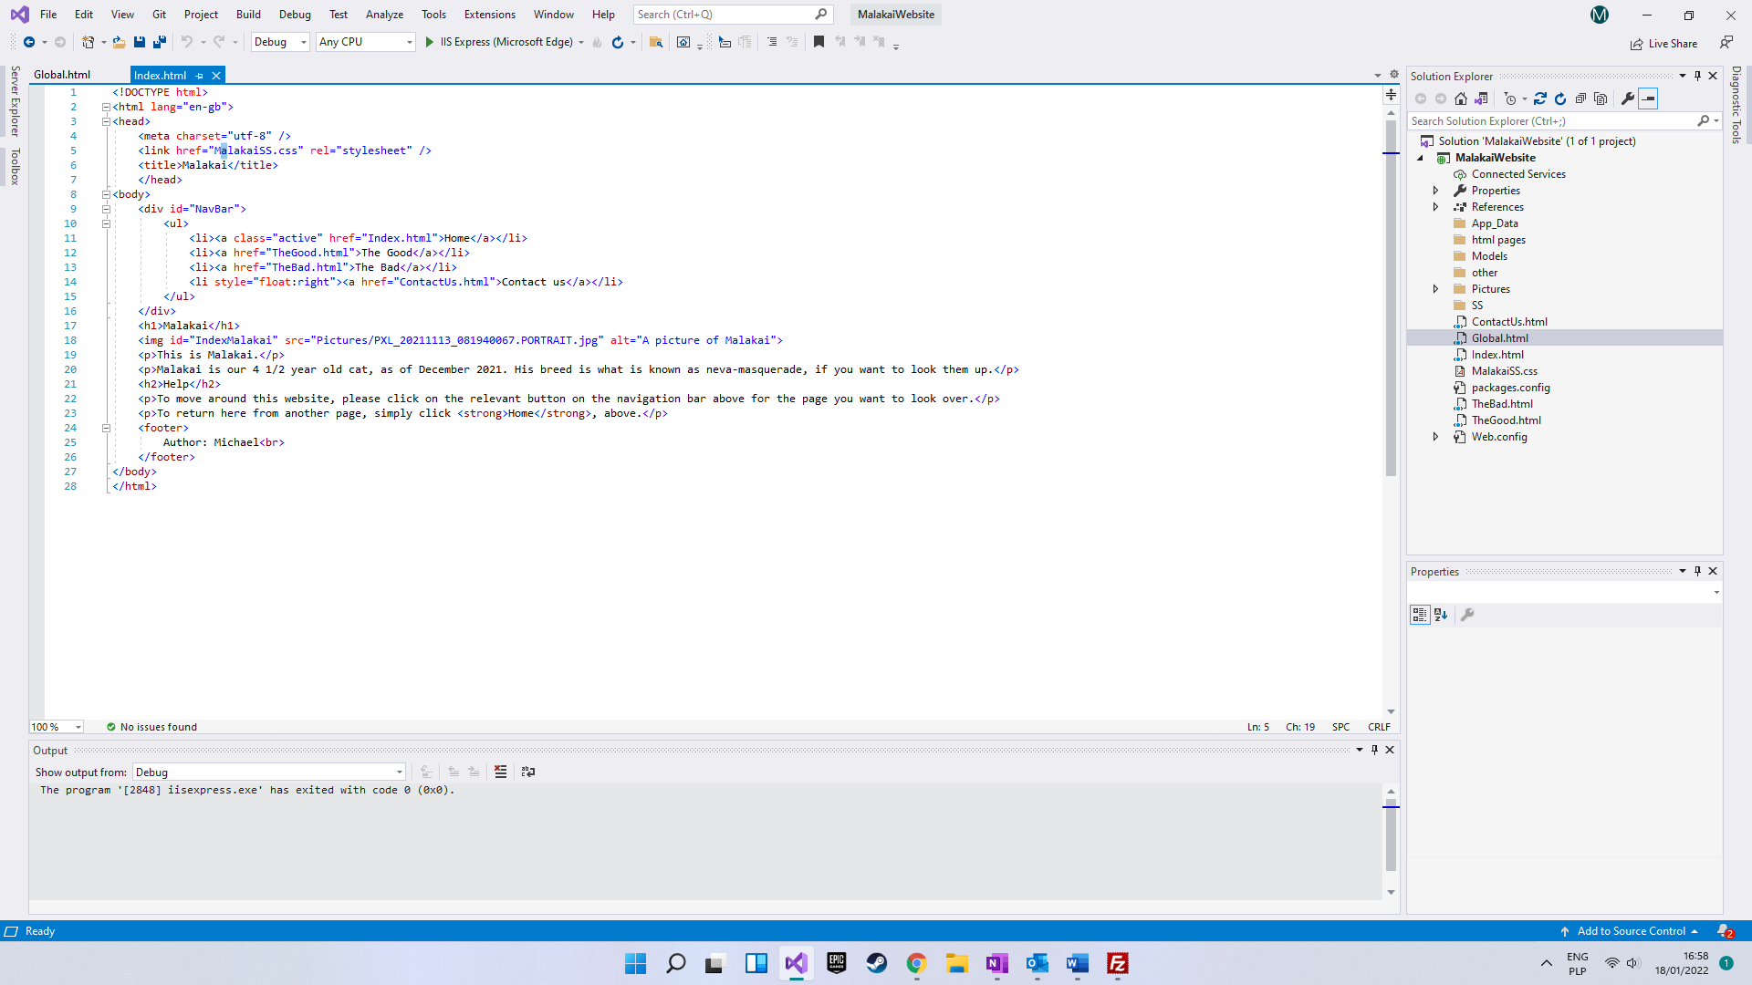

After making the change I would save that page, or all of the pages by clicking one of the buttons:



After doing so I would use Visual Studio’s ISS to load up the relevant page in a browser to check that the fix is complete.